**CUSTOMER CARE REGISTRY**

**DATA FLOW DIAGRAM**

**& USER STORIES**

**TEAM MEMBERS**

|  |  |
| --- | --- |
| **TEAM LEADER** | VIGNESHWARAN D |
| **TEAM MEMBERS** | SURESH KUMAR R |
| **TEAM MEMBERS** | SURIYAN D |
| **TEAM MEMBERS** | AZIL KRISHNAN S |

**TEAM DETAILS**

**Team No :** PNT2022TMID31494

**College Name:** Dr.N.G.P.Institute of Technology

**Department :** ELECTRONICS AND COMMUNICATION ENGINEERING

PROJECT DESIGN PHASE-II

DATA FLOW DIAGRAM & USER STORIES

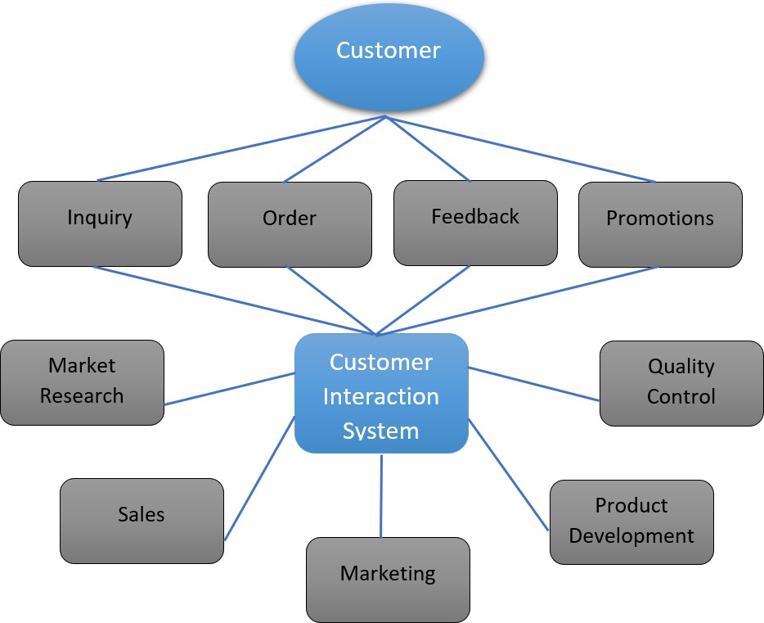

**User Stories**

Using the below table to list the user stories.

|  |  |  |  |  |  |  |
| --- | --- | --- | --- | --- | --- | --- |
| **User Type** | **Functional Requirement** | **User Stories Number** | **User Story / Task** | **Acceptance criteria** | **Priority** | **Release** |
| Customer (Users) | Enrollment | USN-1 | The clients or the users can enroll using authenticate the code given to the message or mail. | Using the instrument panel the clients can access their account. | High | Sprint-1 |
|  | Login | USN-2 | Using the code in mail the clients can login the account. | Panel is given to access the account. | High | Sprint-2 |
|  | Panel | USN-3 | Clients can view their  suggestions and order. | Panel furnish information  to the clients. | Low | Sprint-3 |
|  | Order Formation | USN-4 | Clients can locate orders with complete explanation. | Clients will interrogate. | Medium | Sprint-2 |
|  | Address column | USN-5 | Clients will get a clear view by their interrogations with staffs. | Questions are explained by associates. | High | Sprint-3 |
|  | Forgot Password | USN-6 | Using this alternative the clients can reset their password when they were forgotten. | Account will not erased  when using this option. | Medium | Sprint-4 |
|  | Order Details | USN-7 | Status of clients order were view ed by them. | Used for forever compassion. | Medium | Sprint-1 |

|  |  |  |  |  |  |  |
| --- | --- | --- | --- | --- | --- | --- |
| Customer Interaction System | Login | USN-1 | Users can login using code or  password. | Panel is given to access the  account. | High | Sprint-2 |
|  | Panel | USN-2 | Clients can view their orders using the panel. | Panel furnish information to the customers. | Low | Sprint-3 |
|  | Address Column | USN-3 | Clients will get a clear view by their interrogations with staffs | queries are detailed by customer care associates. | High | Sprint-3 |
| I | Forgot Password | USN-4 | Using this alternative the clients can reset their password when they were forgotten the password. | Creating multiple account for forgetting password will be decreased. | Medium | Sprint-1 |
|  | Order Details | USN-4 | Status of clients order were view ed  by them. | Used for forever compassion. | Medium | Sprint-2 |

THANK YOU